1.What are the two values of the Boolean data type? How do you write them?

**Answer :** True and False, using capital T and F, with the rest of the word in lowercase

2. What are the three different types of Boolean operators?

**Answer :** AND , OR and NOT

3. Make a list of each Boolean operator's truth tables (i.e. every possible combination of Boolean values for the operator and what it evaluate ).

**Answer :** True AND True is True

True AND False is False

False AND True is False

False AND False is False

True OR True is True

True OR False is True

False OR True is True

False OR False is False

True NOT True is False

True NOT False is False

False NOT True is True

False NOT False is True

4. What are the values of the following expressions?

**Answer :**

(5 > 4) and (3 == 5) = False

not (5 > 4) = False

(5 > 4) or (3 == 5) = True

not ((5 > 4) or (3 == 5)) = False

(True and True) and (True == False) = False

(not False) or (not True) = True

5. What are the six comparison operators?

**Answer :**

| **Operator** | **What it means** |
| --- | --- |
| == | Equal to |
| != | Not equal to |
| < | Less than |
| > | Greater than |
| <= | Less than or equal to |
| >= | Greater than or equal to |

6. How do you tell the difference between the equal to and assignment operators?Describe a condition and when you would use one.

**Answer :**

The “=” is an assignment operator is **used to assign the value on the right to the variable on the left**. The '==' operator checks whether the two given operands are equal or not.

e.g.

For example:-

x=10 y=20 z=20

(x==y) is False because we assigned different values to x and y.

(y==z) is True because we assign equal values to y and z.

A condition is an expression used in a flow control statement that evaluates to a Boolean value.

7. Identify the three blocks in this code:

**Answer :**

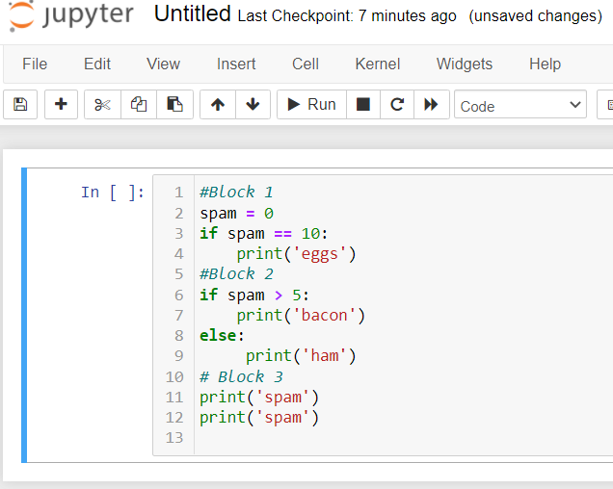

8. Write code that prints Hello if 1 is stored in spam, prints Howdy if 2 is stored in spam, and prints Greetings! if anything else is stored in spam.

**Answer :**

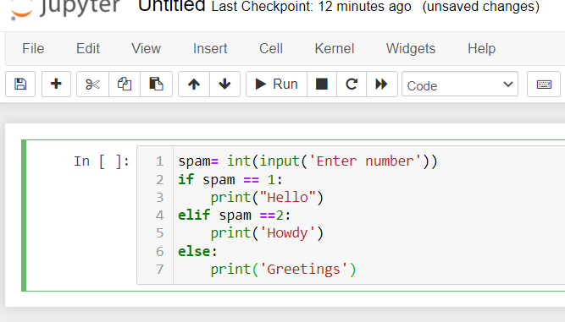

9.If your programme is stuck in an endless loop, what keys you’ll press?

**Answer :** Press CTRL+C to stop a program stuck in an infinite loop.

10. How can you tell the difference between break and continue?

**Answer :**The Python break statement stops the loop in which the statement is placed. A Python continue statement skips a single iteration in a loop. Both break and continue statements can be used in a for or a while loop

11. In a for loop, what is the difference between range(10), range(0, 10), and range(0, 10, 1)?

**Answer :**They all do the same thing. The range(10) call ranges from 0 up to (but not including) 10, range(0, 10) explicitly tells the loop to start at 0, and range(0, 10, 1) explicitly tells the loop to increase the variable by 1 on each iteration.

12. Write a short program that prints the numbers 1 to 10 using a for loop. Then write an equivalent program that prints the numbers 1 to 10 using a while loop.

**Answer :**

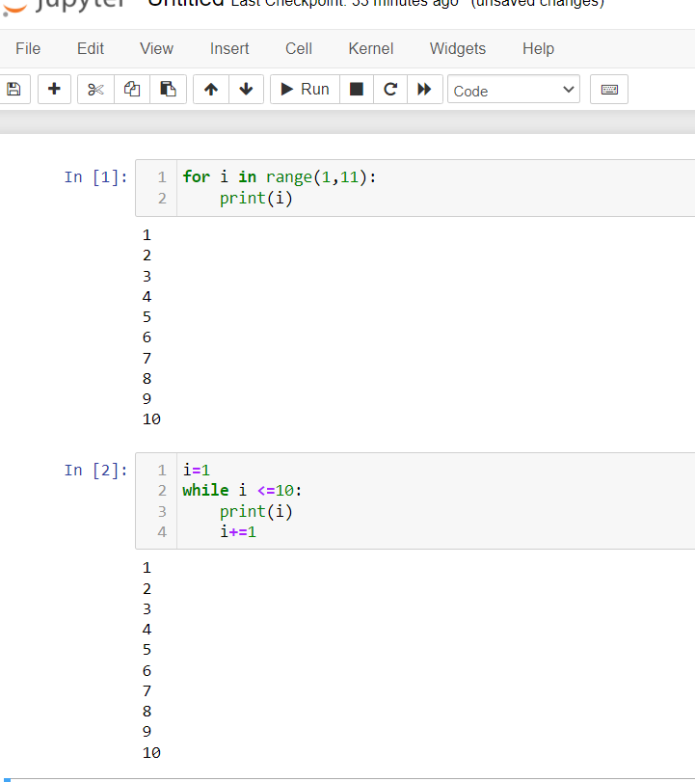

13. If you had a function named bacon() inside a module named spam, how would you call it after importing spam?

**Answer :** This function can be called with spam.bacon().